**Analysis of Hospital Data:**

**Demographic Trends and Distributions in task one**

**Introduction**

This report presents an analysis of hospital data, focusing on demographic trends and distributions. The dataset includes information on patient demographics, satisfaction scores, and administrative details. The analysis aims to uncover patterns and insights that can inform hospital management and policy decisions.

**Data Cleaning and Preparation**

The initial steps involved loading the dataset and performing data cleaning. Missing values were removed, and duplicates were eliminated to ensure the integrity of the data. The cleaned dataset contained 1,077 entries with 12 columns, including patient ID, gender, age, satisfaction score, race, and wait time.

**Demographic Distributions**

The analysis explored the distribution of patients across various demographic categories, including gender, race, and age.

**Gender Distribution**

The dataset revealed a nearly balanced gender distribution, with 495 female patients, 580 male patients, and 2 patients who did not specify their gender.

***Figure 1: Gender Distribution***

* *This bar chart shows the count of patients by gender, highlighting the slight predominance of male patients.*

**Race Distribution**

Patients were categorized into several racial groups, with the following distribution:

* African American: 227
* Asian: 119
* Declined to Identify: 118
* Native American/Alaska Native: 62
* Pacific Islander: 54
* Two or More Races: 178
* White: 319

**! Race Distribution**

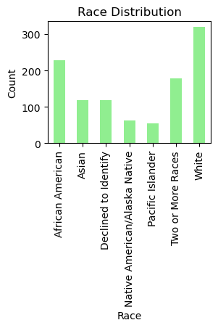

***Figure 2: Race Distribution***  
 This bar chart illustrates the racial composition of the patient population, with White and African American patients being the largest groups.

**Age Distribution**

Patients were grouped into age categories, revealing the following distribution:

* 0-18 years: 244
* 19-35 years: 237
* 36-50 years: 210
* 51-65 years: 204
* 66-80 years: 182
* 81-100 years: 0

**! Age Category Distribution**

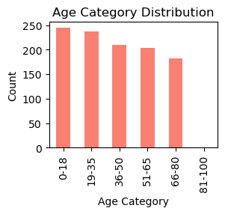

***Figure 3: Age Category Distribution***  
This bar chart shows the number of patients in each age category, indicating a higher concentration of younger patients.

! Age Distribution

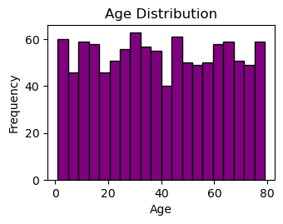

***Figure 4: Age Distribution***  
This histogram displays the distribution of patient ages, with a noticeable peak in the younger age groups.

**Demographic Trends Analysis**

The analysis provided insights into the demographic trends within the hospital’s patient population:

* **Gender Distribution**: The patient population is almost evenly split between males and females.
* **Race Distribution**: The majority of patients are White, followed by African American and patients of Two or More Races.
* **Age Distribution**: The average patient age is approximately 39.81 years, with a significant number of patients under 50 years old.

**Conclusion**

The demographic analysis of the hospital data reveals important trends that can help in understanding the patient population better. These insights can guide hospital management in resource allocation, patient care strategies, and policy formulation to improve overall patient satisfaction and operational efficiency.